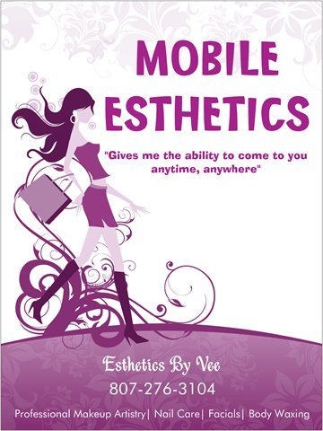  Self-Care Workshops  Certified Esthetician Technician, Vanessa Big George offers a wide variety of services to satisfy everyone’s needs. Being specially trained to properly handle many health conditions that include; diabetes, pregnancy, skin conditions and muscle & nerve problems. Providing a manicure or pedicure workshop will include; nail shaping & cuticle grooming, removing calluses on the feet, relieving muscle tension by stimulating blood circulation with massages and polishing. Providing make-up workshops will include a basic makeover application and teaching basic techniques for any occasions like; day/night wear or preparing for an interview. Self-care is important to maintain a healthy relationship with yourself, sometimes called self-love. It produces positive feelings, which improves confidence and self-esteem. The following services guarantees to leave you feeling stress-free, pain-free, pampered and relaxed. | Workshop Services  Manicure’s & Pedicure’s  ────  Professional Makeup Artistry  ────  Body Waxing  ────  Group or Hourly rates available  Mileage rates for locations outside of Fort Frances, ON  ────  Contact me for more information and availability  Esthetics By Vee  1123 Fourth Street East Fort Frances, ON P9A 1T6  807-276-3104  estheticsbyveee@gmail.com  Available Fri-Sun

Self-care workshops

Pricing varies on group size and the length of the workshops. For small groups of 5 people or less there will be a per-person discounted group rate for services like; make-up application, manicure’s or pedicure’s and body waxing. For large groups of 6 people or more there will be an hourly rate charge.
Hourly rates per day
- 1-3 hours - $50/hour charge
- 4 hours - $40/hour charge
- 5 or more hours - $35/hour charge

Millage rates
- Basic rate per KM

